**GUJARAT UNIVERSITY**



PROJECT REPORT ON

Freeiva

Developed By :

Msc.IT Data Management & Visual Insight (5 Years Integrated)

Semester – 3

Jayesh Parmar

Kamlesh Patil

Yash Patil

**Internal Guide:**

Ms . Neepa Mandaliya

**TABLE OF CONTENT**

1. Acknowledgement

2. Introduction

2.1. project summery

2.2. purpose

2.3. project scope

2.4. tools & technology

3. system planning

4. Feasibility Study

5. System Design

5.1 DFD

5.2 Database Design (Data Dictionary)

5.3 Screen Layout

6. Test Cases

7. Future Enhancement

8. Bibliography

**1. Acknowledgement**

First and foremost, we would like to express us to our Mentor, Ms . Neepa Mandaliya , who was a continual source of inspiration. He pushed us to think imaginatively and urged us to do this homework without hesitation. His vast knowledge, extensive experience, and professional competence in Data Science enabled us to successfully accomplish this project. This endeavour would not have been possible without his help and supervision. We could not have asked for a finer mentor in our studies. This initiative would not have been a success without the contributions of each and every individual. We were always there to cheer each other on, and that is what kept us together until the end.

I’d like to thank The Department Msc.IT Data Management & Visual Insight for providing me with the opportunity to work on the project FREEIVA. Last but not least, I would like to express my gratitude to my Mentors and friends for their valuable assistance, and I am deeply grateful to everyone who has contributed to the successful completion of this project.

We have expressed our experiences in our own simple way. We hope whoever goes through it will find it interesting and worth reading. Constructive feedback is cordially invited.

**2. Introduction**

**2.1 Project Summary**

Our site is a great place to find a wide range of products, both generic and based on certain niches. We can especially target sellers in your neighbourhood who don't have the technology to list their business online. We reach out to these sellers and make them aware of our site so that they can get their products listed with the lowest price online.

On our site, we can introduce you to our coin called PANA. That used to buy and sell products from websites

If you have a tight budget, this product is right for you. It's inexpensive and provides excellent value.

Sellers interested in selling their products on this site can contact us either personally or through the website. If the product matches our high standards, we will reply to that seller and grant them permission to sell their product. After a year, sellers will be subject to a fee if they want to continue selling their products on this site.

**2.2 Purpose**

Our aim is to provide the customer with top quality at a reasonable price. We want you to be happy and satisfied with the purchase you make from my website.

There are many shops in our area with great quality products, but we won't have all the products available online. We will list the products online and provide the physical address so any customer can buy products from our area in their home.

In our website we have put our coin, PANA, so that if a visitor makes a purchase using this coin, then the user will get the item at a much lower price than the real price. Additionally, anyone who uses the website has an opportunity to win the coin from ads and a lucky draw. If you use this site, you'll find it's helpful - success means that whether or not we can find an advertiser for our site, we still want people to be able to experience what it feels like to own PANA and use it towards their purchase on our site**.**

**2.3 Project Scope**

Our website is for everyone who wants a top-quality item but doesn't want to go out and the price of the item should also be very low.

Our goal is to provide as many people as possible with the opportunity to purchase top-quality items at a low price. We're here for everyone who wants an affordable product, but doesn't want to spend their time searching.

Like someone who wants a painting but doesn't have time to go to a painter to get it done or choose one and he doesn't want to get a painting from anyone other than his favourite painter then he can request the painting he wants from our website and that too. Painter's. So, in this way, the things that special people want from the place they want and that too at a cheap price.

We understand how difficult it is to find affordable goods, and that's why we strive to make shopping as easy as possible. Saving money is also easier with us because we want this to be an enjoyable experience for everyone.

Our website is for everyone who wants their shopping to be very easy and less expensive.

**2.4 Tools and Technology**

* **Tools**

Visual Studio Code

Version - 1.74

XAMPP

Version – 8.1.12

* **Technology**

HTML

Version - 5

CSS

Version – 3

PHP

Version – 7.4

JAVASCRIPT

Version – ES2022

**3. System Planning**

System planning is basically use for to deficient the user requirement and studying the present system to verify the problem. It is a process of gathering information about the current system, analysing it and then developing a plan for the new system. This plan includes specifying the goals of the new system, determining how these goals will be met, and outlining the steps necessary to implement the new system.

When we started planning our website, one of the first things we did was come up with an idea that is original and different from what you would expect.

All of us team members got the idea after thinking about it, so we looked at different sites like this to see what they do.

After taking their reference, they came to find out that these websites are not easy to build and they would need to do more work. Even after all this extra time, they decided not to give up on the idea.

After that, the whole team got together and decided on the website's layout. We established what features the site would have and where they'd be located. After that, we had a blueprint of the site on paper.

First, we took the same structure and gave each team member different pieces to work on. They all got started working, and slowly created content. The members then fit everything together, and before we knew it, we had a website.

We're just getting started with our website. We like the look of it so far and we showed it to Neepa Ma’am for her input. She gave us some feedback and we decided to change some things, which meant we had to make a lot of changes to the entire design.

We changed a few things here and there and finally everything was ready.

System requirement specification includes following requirement specification for this project:

• Hardware Requirement Specification

• Software Requirement Specification

**Hardware Requirement Specification**

Any Personal Computer with following hardware configuration:

**Developer Requirement :**

Processor : Minimum Intel Core i3 – 2.4 GHz

RAM : +6 GB

Hard Disk : 128 GB

Internet : +0.5 Mbps network bandwidth

**Server Requirement :**

Processor : Intel Core Version (2 GHz)

RAM : +2 GB

Hard Disk : Not Required

Internet : 0.5 Mbps network bandwidth

**Client (User) Requirement :**

Any laptop or smartphone with internet enabled and a browser can be used to access this site.

**Software Requirement Specification**

**Developer Requirement :**

Platform : Windows OS.

IDE : Vs Coad

Tools : Vs Coad & XAMPP

Database Server: XAMPP & MySQL

Storage : Minimum storage required to run OS &App.

**Server Requirement :**

Platform: Any

Tools: java &packages

Database Server : MySQL.

**Client (User) Requirement :**

Any laptop or smartphone with internet enabled and a browser can be used to access this site.

**4. Feasibility Study**

We've spent a significant amount of effort and time to build this website from September 2022 to December 2022

September 5, 2022 : Initiate Project

September 15, 2022 : The Project Kick-Off Meeting is where we'll share the entire project brief with you and discuss your goals for the project. Expect to be a part of this meeting so that we’re on the same page from the beginning.

November 1, 2022 : Start website design for e-commerce

November 25, 2022 : Complete website design for e-commerce

December 1, 2022 : We are happy to start testing the online e-commerce site.

December , 2022 : This is the point where your website is completed, and ready to launch for everyone to see.

**5. System Design**

**5.1 DFD**

**5.2 Database Design (Data Dictionary)**

**5.3 Screen Layout**

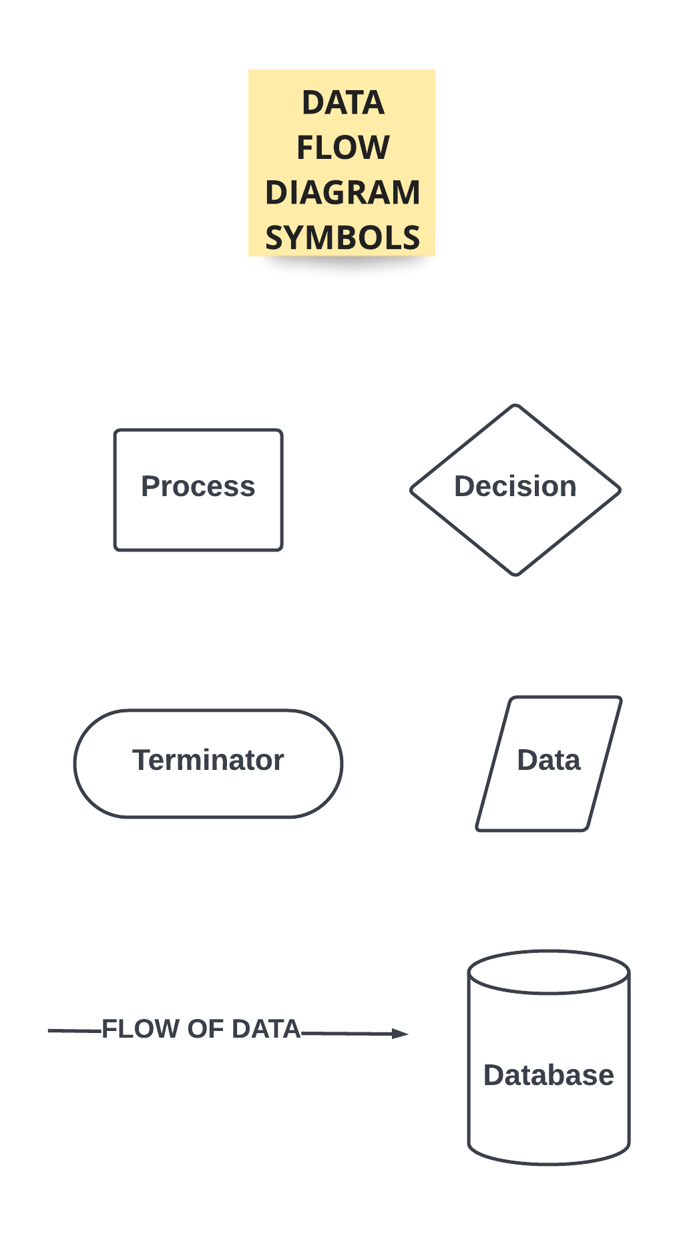

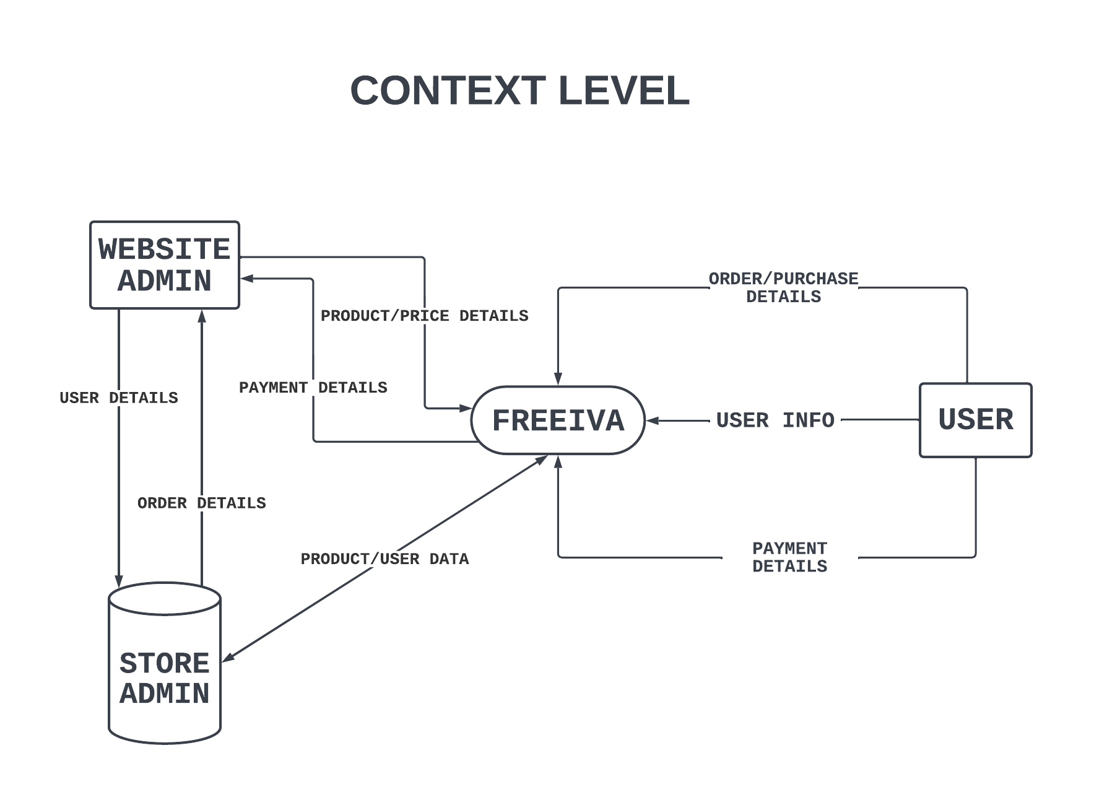

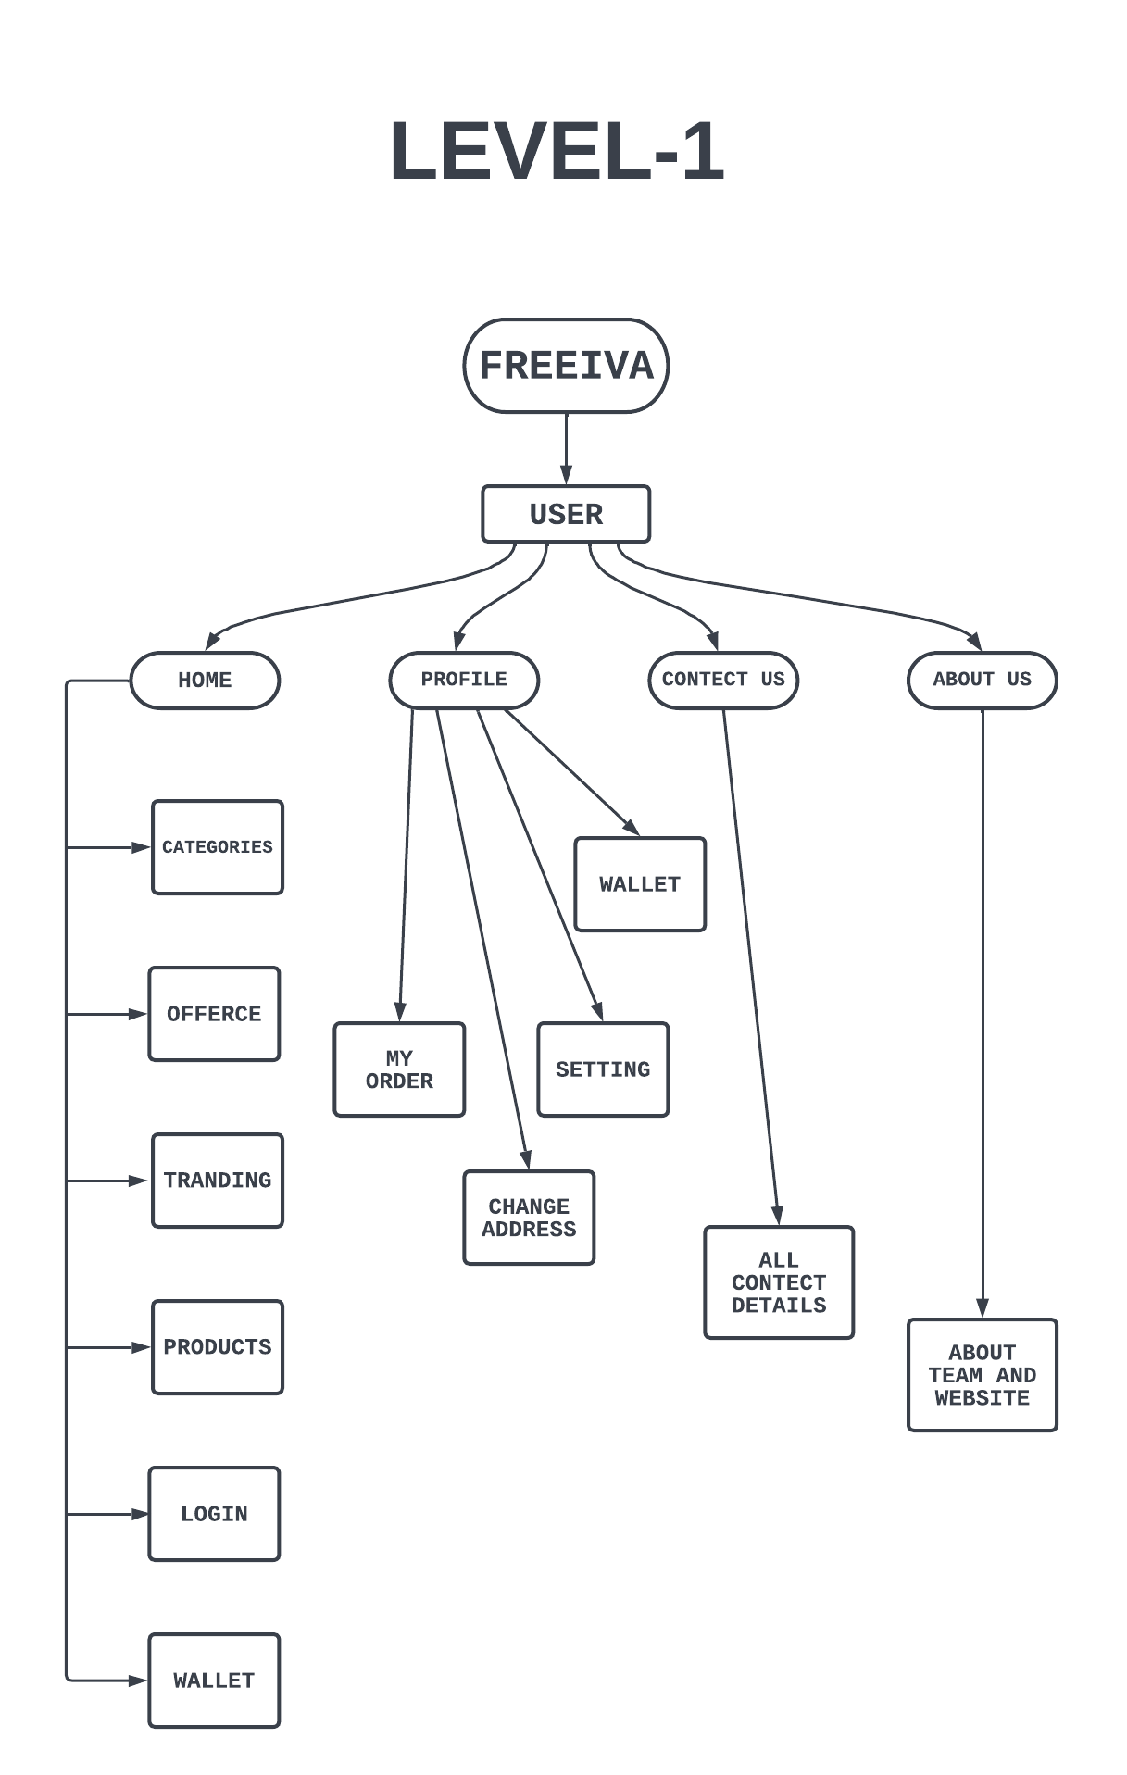

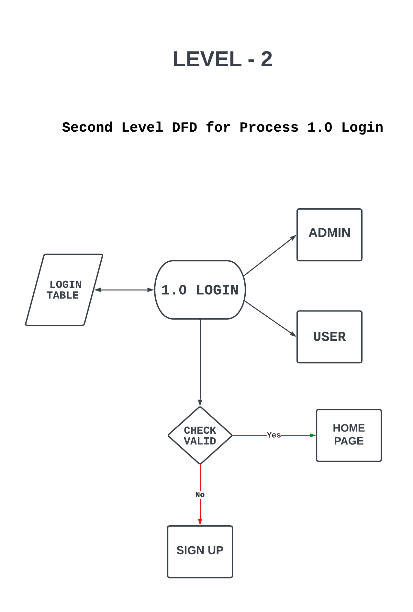

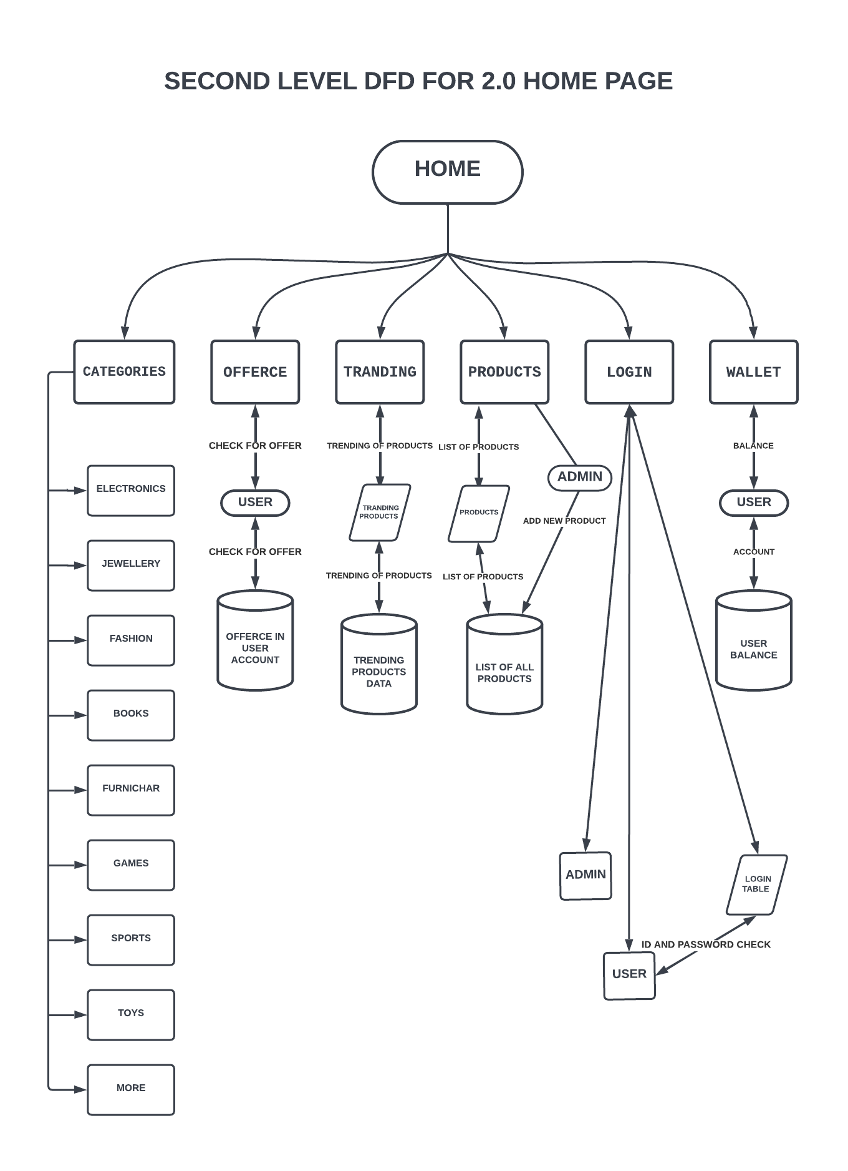

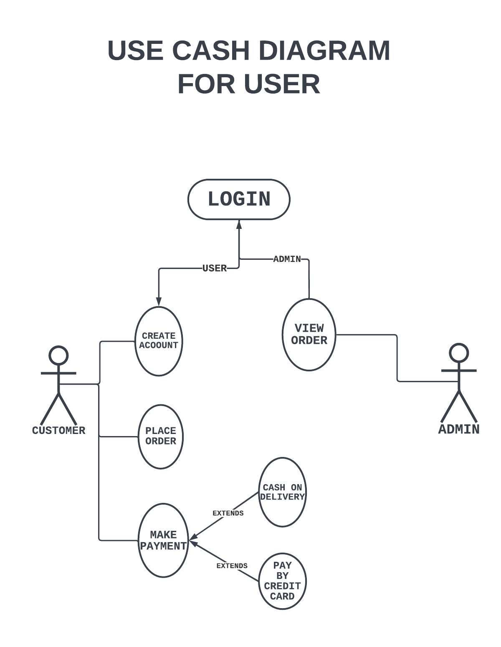

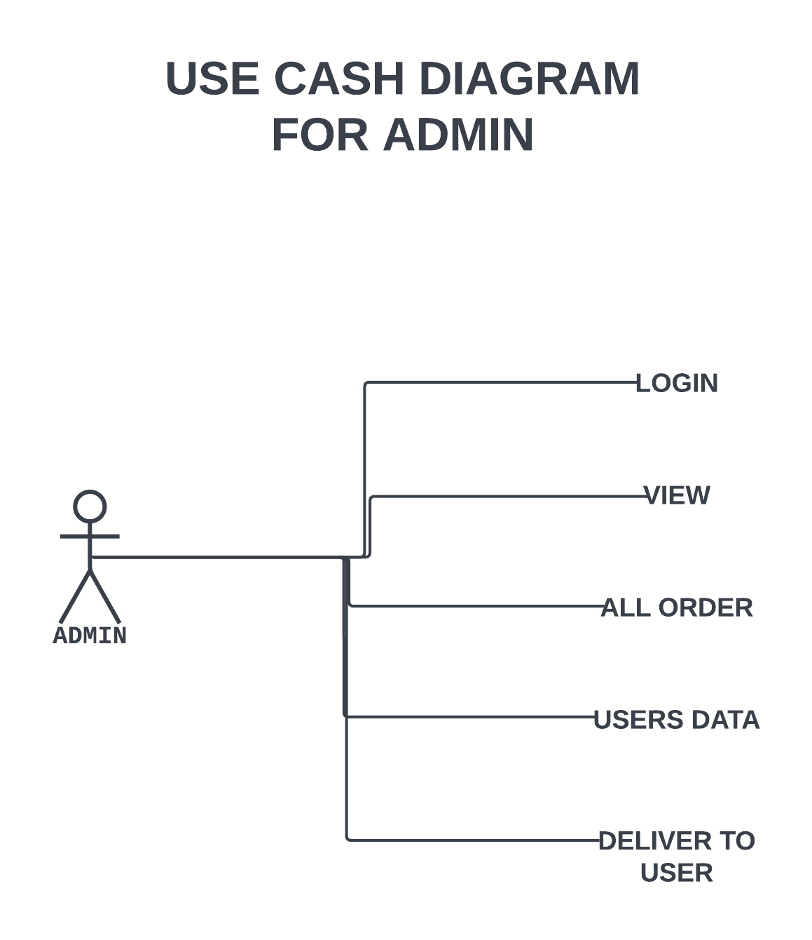

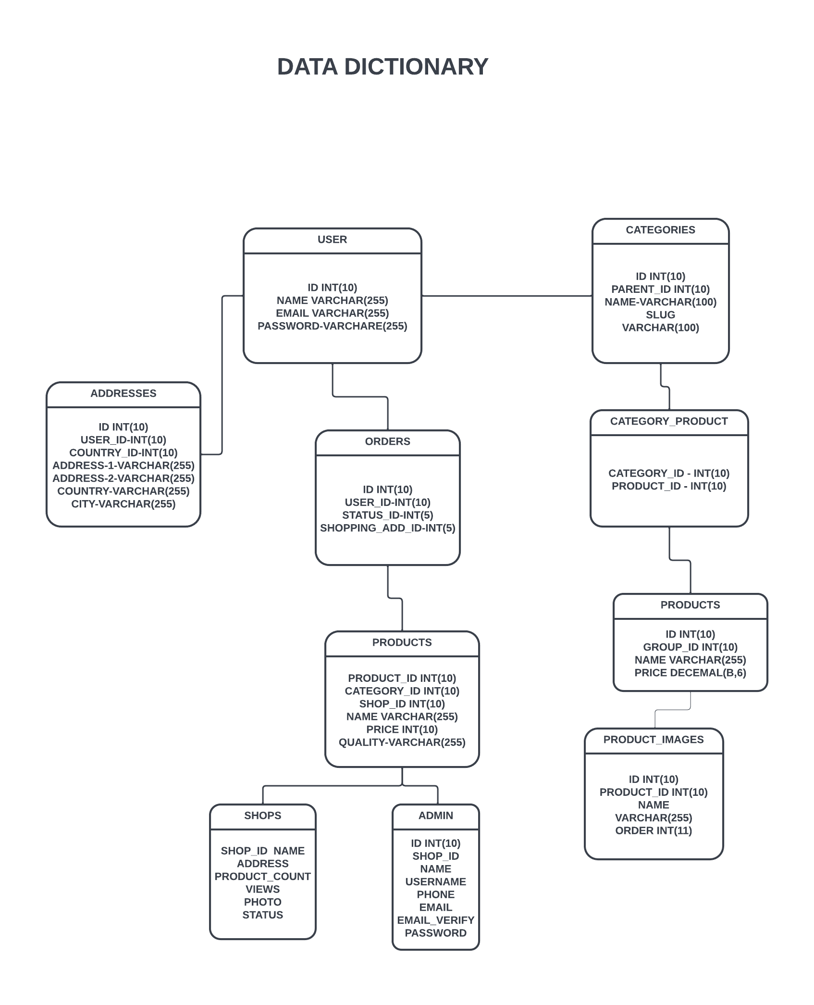

|  |  |
| --- | --- |
| **NO** | **TABLE NAME** |
| 1 | LOGIN TABLE |
| 2 | PRODUCT TABLE |

**DATA DICTIONARY**

**LOGIN TABLE**

THIS TABLE USE TO STORE USER EMAIL ID AND PASSWORD

Constraints : Primary Key :- Id

|  |  |  |  |
| --- | --- | --- | --- |
| **FILED NAME** | **TYPE** | **SIZE** | **DESCRIPTION** |
| EMAIL | VARCHAR | 50 | IT STORES EMAIL DETAILS |
| PASSWORD | INT | 10 | IT STORE PASSWORED |

**PRODUCT TABLE**

THIS TABLE USE TO STORE PRODUCT PURCHASE DETAILS

Constraints : Primary Key :- Id

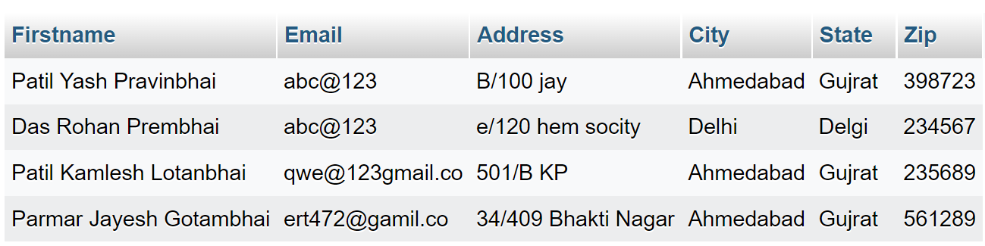

**HOME**

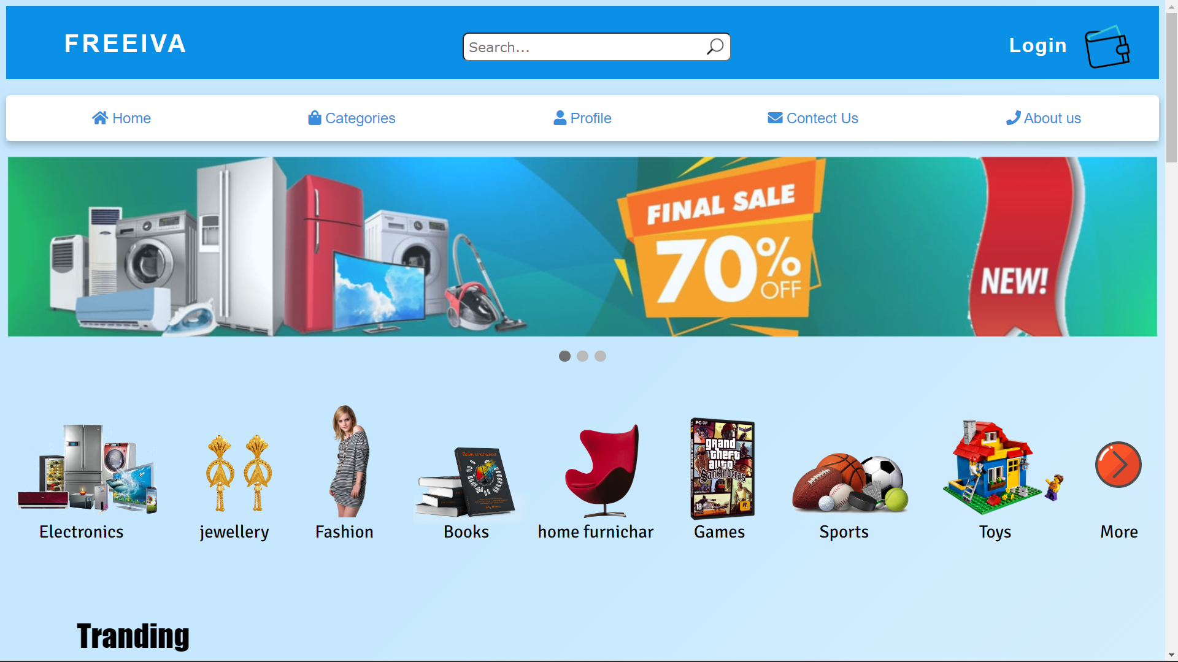**PAGE**

**CATEGORIES**

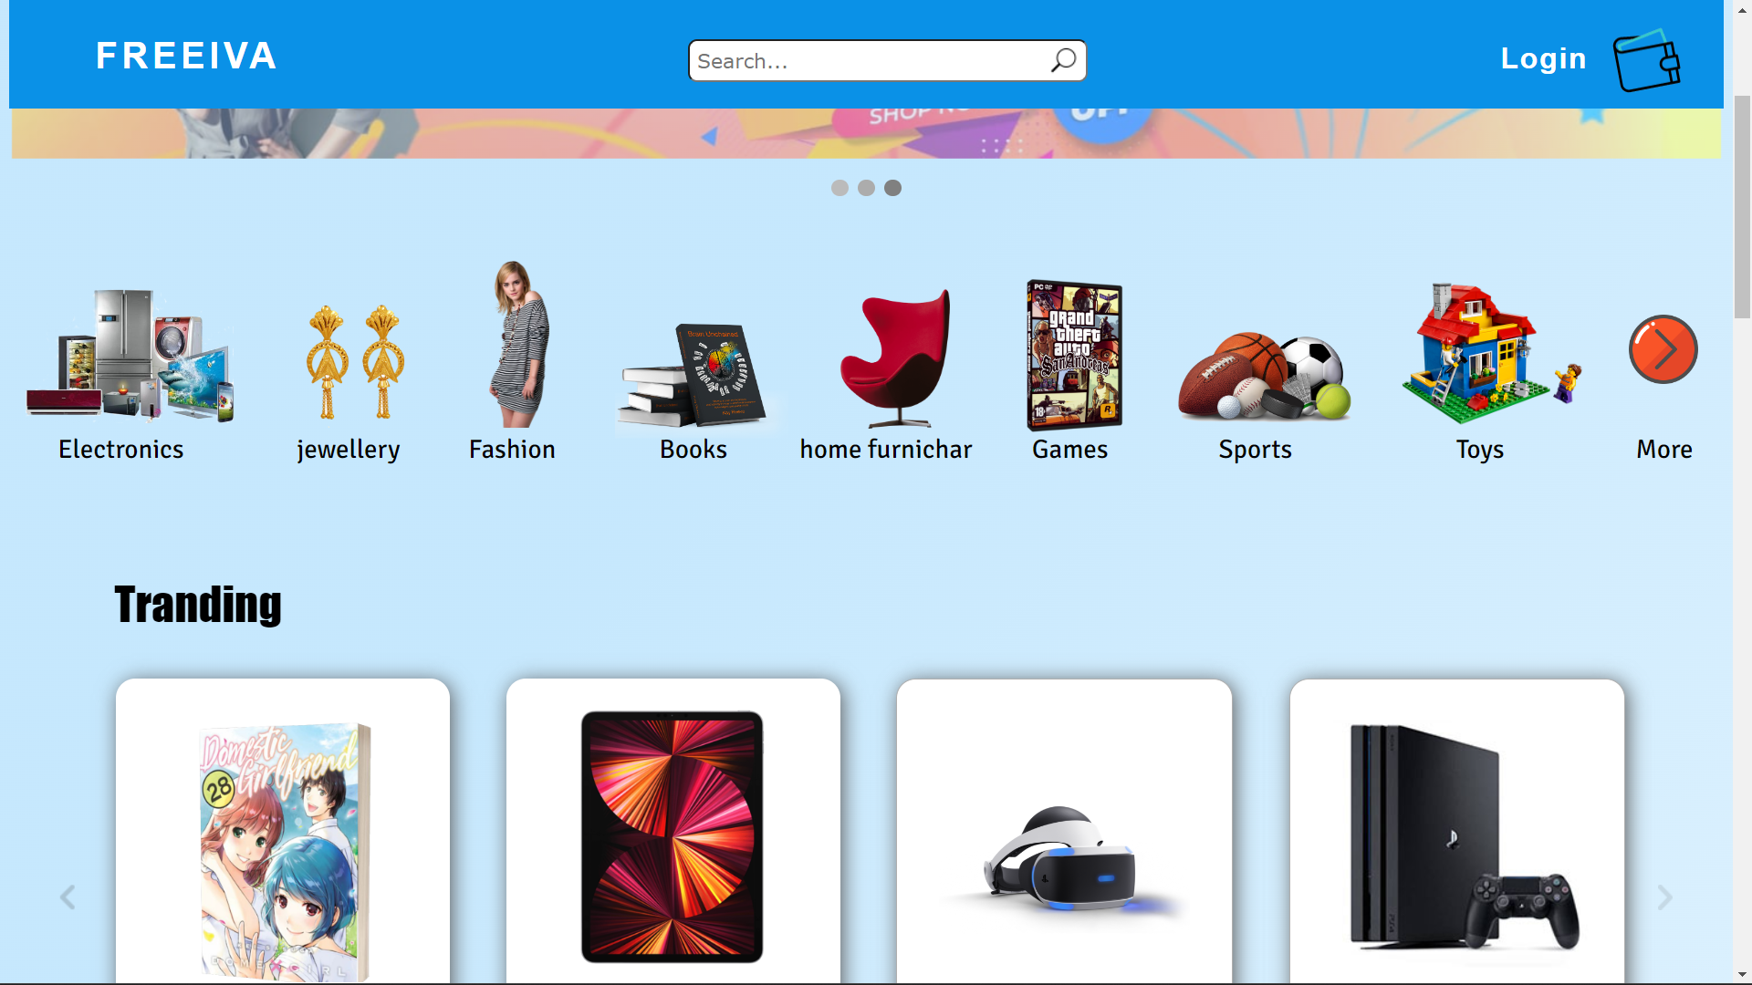

**TRENDING**

**CART**

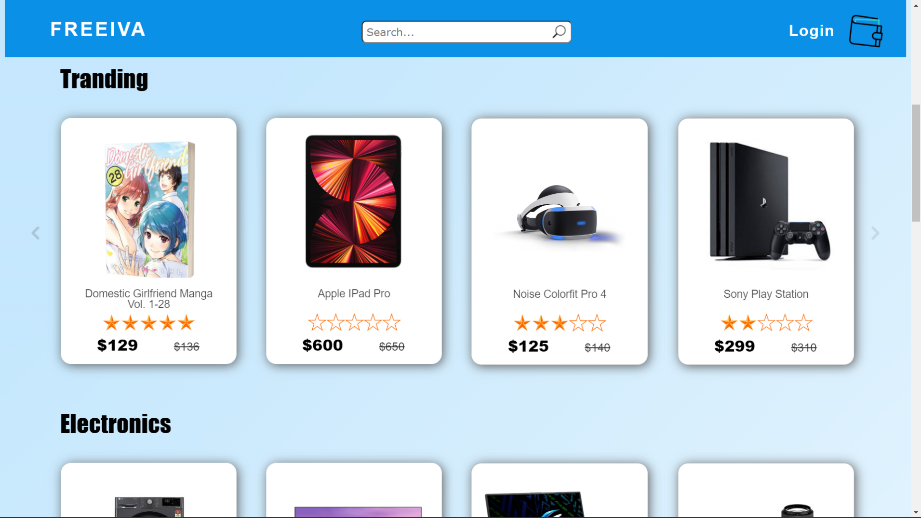

**GAMES**

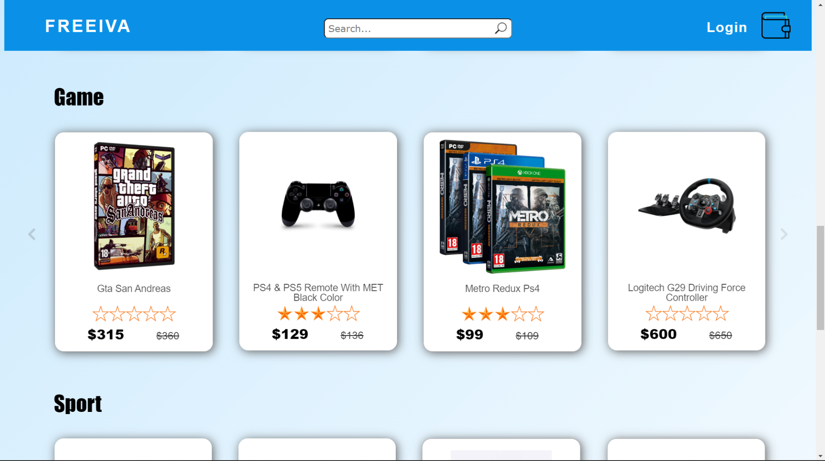

**LOGIN**

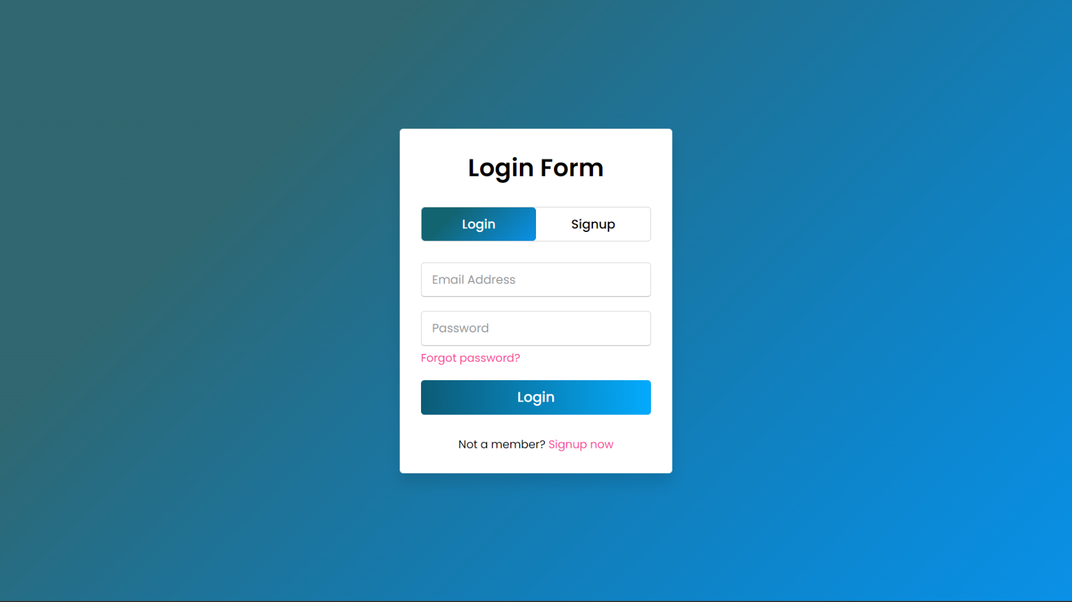

**SIGNUP**

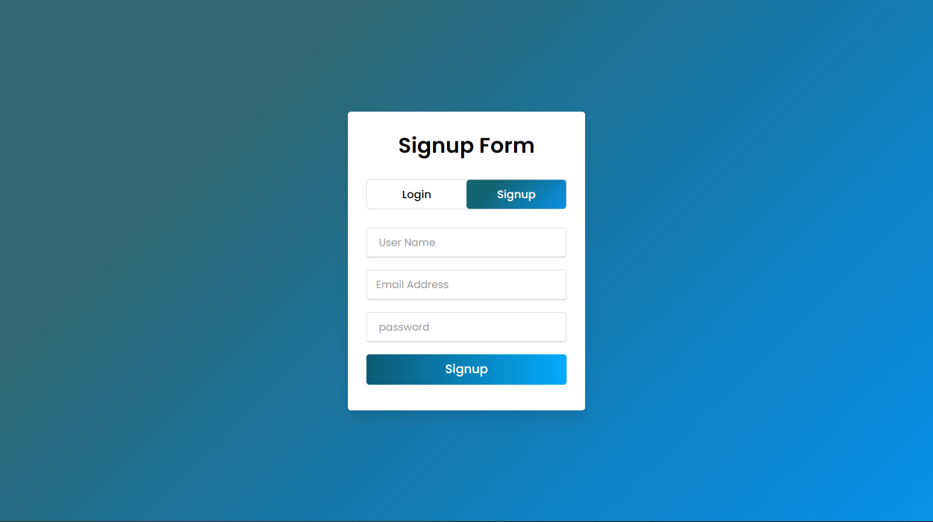

**ELECTRONICS**

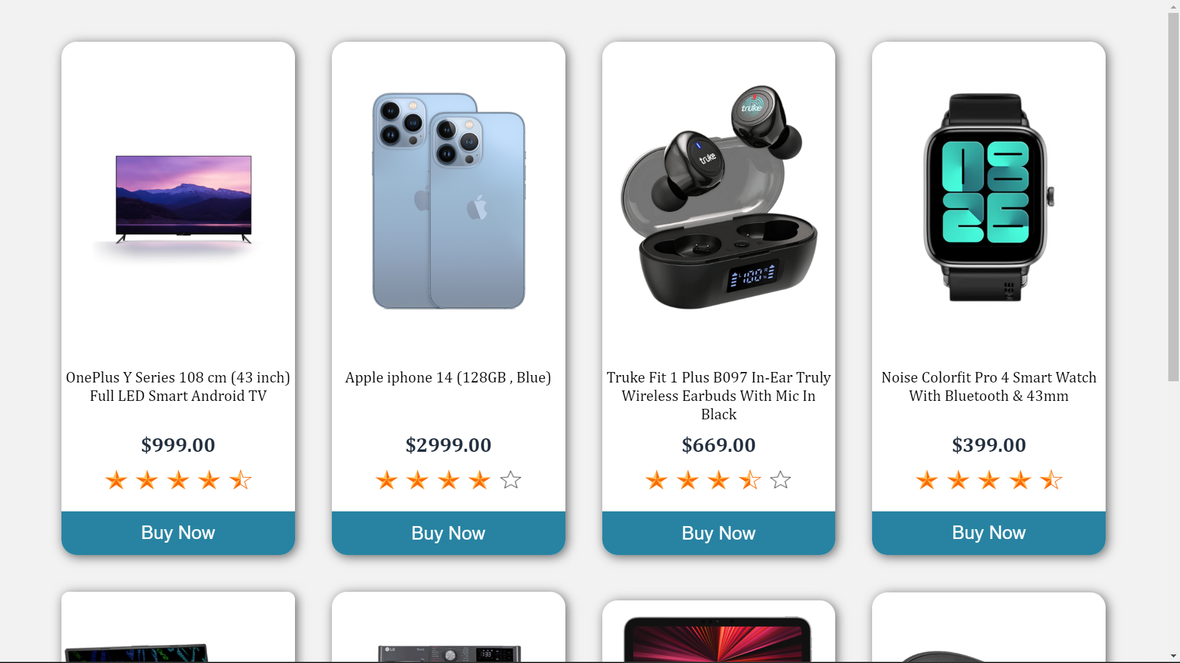**PAGE**

**BOOKS**

**PAGE**

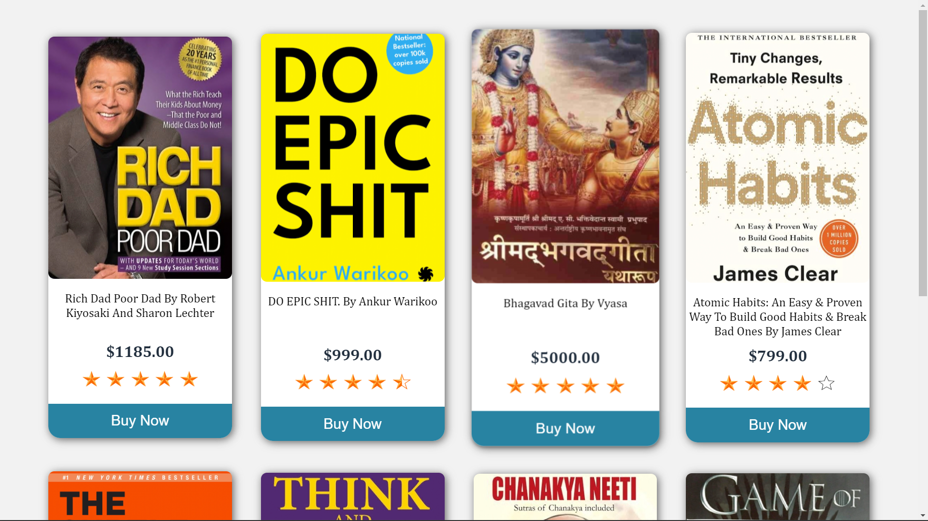

**FASHION**

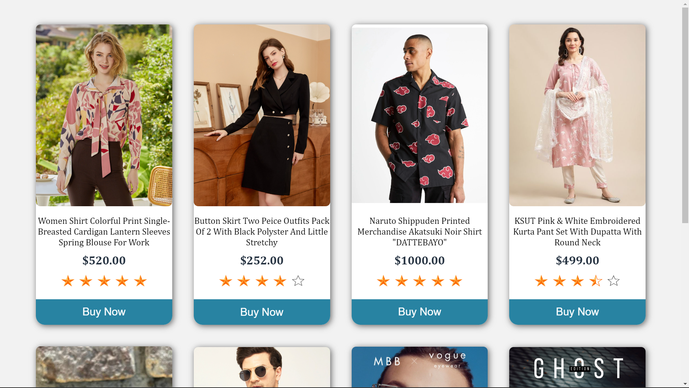**PAGE**

**PRODUCT**

**PAGE**

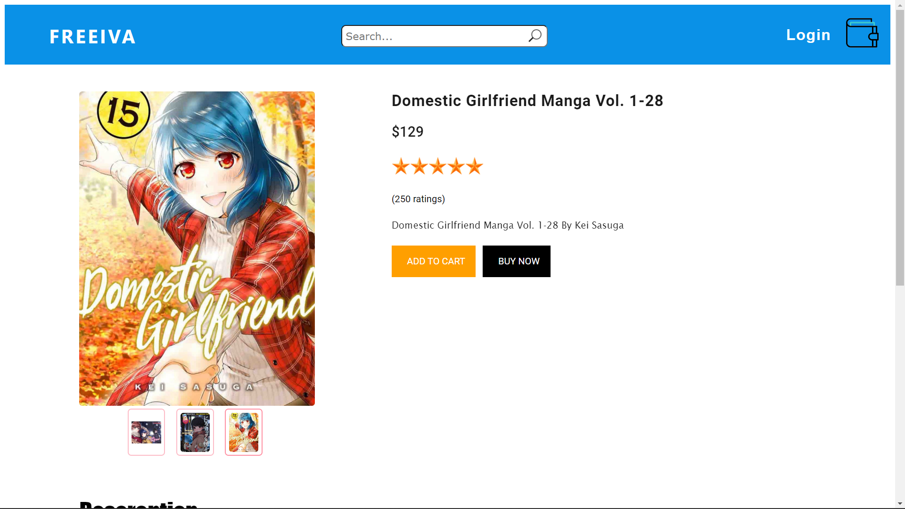

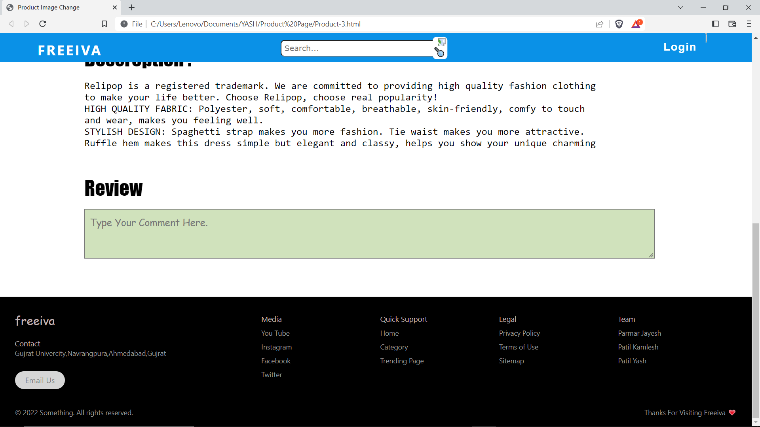

**CHECKOUT PAGE**

**ADDRESS**

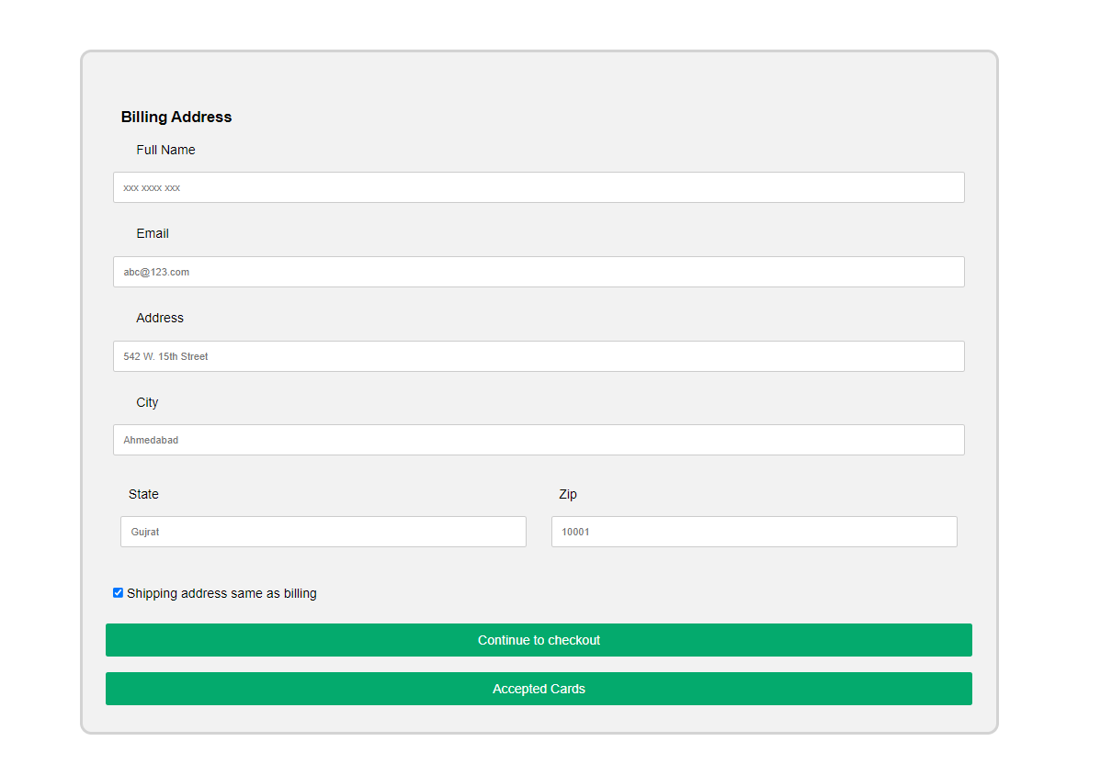

**CHECKOUT PAGE**

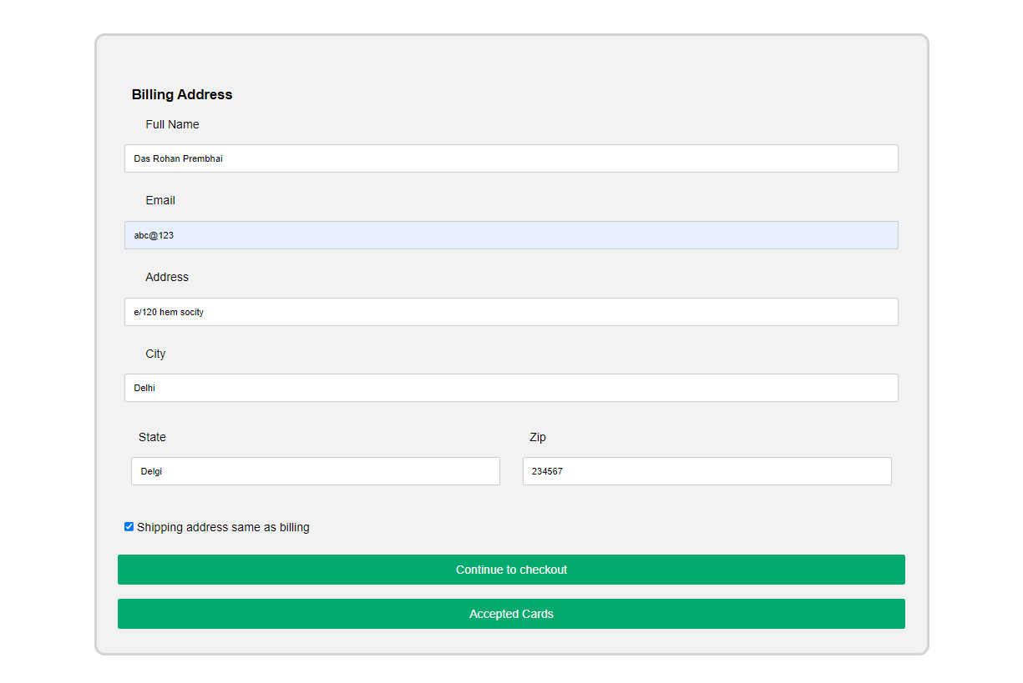**PAYMENT**

**6.TEST CASES FOR FREEIVA**

|  |  |  |  |  |  |
| --- | --- | --- | --- | --- | --- |
| NO | TITLE | EXPECTED  RESULT | ACTUAL  RESULT | SOLUTION | STATUS |
| 1 | Text decoration | Remove default decoration from the hyperlink text | Not remove after and before click decoration | In CSS  text decoration : none: | Success |
| 2 | Colure gradient | Apply gradient colour in a submit button | Not proper gradient apply | In CSS:  background: -webkit-linear-gradient(right, #06daff, #04abff, #0d5b75, #06bcf8); | Success |
| 3 | Setup of login and signup page | Apply animation between login and sign up page | Animation not work | const loginBtn = document.querySelector  ("label.login");          const signupBtn = document.querySelector  ("label.signup"); | Success |
| 4 | Cart size | cart size and animation | Not proper animation and cart size work | Change all size into percentage | Success |
| 5 | Image set in cart | Add proper image with animation | Image size not properly added with animation | Change image pixels and margin | Success |
| 6 | Popup when wrong login id and password | Popup when user enter wrong id and password | Popup not work properly with database | Landing on sign up page when user enter wrong id and password | Success |
| 7 | Banner animation | Animate banner continually | Banner not continually animate | Add time of 3seconds in animation | Success |

**6. Future Enhancement**

One of the next features we’re thinking about adding to our website is games and advertisements. This would give any user the opportunity to earn money by playing games or watching ads. Then, they can use their earnings to purchase items on our site.

We will look for ways to streamline and improve our payment features in the future. Currently, we only offer credit card payments and cash on delivery.

**7. BIBLIOGRAPHY**

Web reference :

[www.w3school.com](http://www.w3school.com)

[www.javatpoint.com](http://www.javatpoint.com)

[www.stackoverflow.com](http://www.stackoverflow.com)

YouTube channel :

<https://www.youtube.com/@CodingLabYT>

BUY EVERYTHING FOR FREE

BUY EVERYTHING FOR FREE

**THANK YOU**